- General information

Incident Report

Seriousness of incident: accident near accident other
Date of incident reported by tour leader name of tour
Place of incident GPS co-ordinates: N and W
Description of incident Actions taken by leader

- Personal information – Please note that one form should be used for each person
Name of passenger tel. no. email
Description of injury
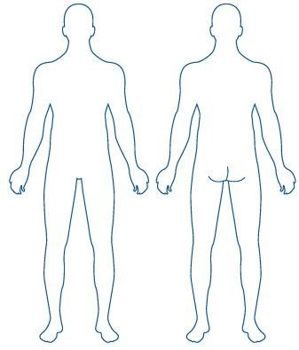
Please indicate the position of injuries on the drawings provided:

Was the person transferred to hospital? yes no Person involved refused hospital treatment yes no Transported by ambulance? yes no
Any other type of transport? Were the police called to the scene? yes no
Other rescue teams involved, which?

- Passengers
Were any other group members in need of trauma support? yes no
Was trauma support offered? yes no Passengers declined
Other actions taken concerning passengers
Witnesses to the accident:

Name tel. no. email nationality Name tel. no. email nationality
Name tel. no. email nationality

- Organisation
Were directors of the company notified? Who? Time of notification

Was the insurance company notified about the incident? yes no
Other details which must be noted
Signature of person filing in the report Signature of tour leader, if other
Actions taken in the wake of the incident, if any:

